LINE OF DUTY CRITERIA FOR INCLUSION ON THE ARIZONA POLICE CANINE MEMORIAL

For the purpose of this Memorial, “Law Enforcement Canine” means a canine involved in crime control or reduction and who is directly employed full-time by a local, county, state or federal law enforcement agency and assigned to a law enforcement duties. For the purpose of this memorial, correctional officer’s canines are also eligible for consideration for inclusion on the memorial.

“Line of duty” means any action which an officer, assisted by his canine, is obligated or authorized by law, rule, regulation, written condition of employment services to perform, or for which the officer is compensated by the public agency he or she serves, which meets the preceding requirements.

The term “killed in the line of duty” means a law enforcement canine has died as a direct result of an injury sustained in the line of duty. This includes canines that, while in an off-duty capacity, are killed via criminal act due to their assignment to a law enforcement agency (i.e., poisoning).

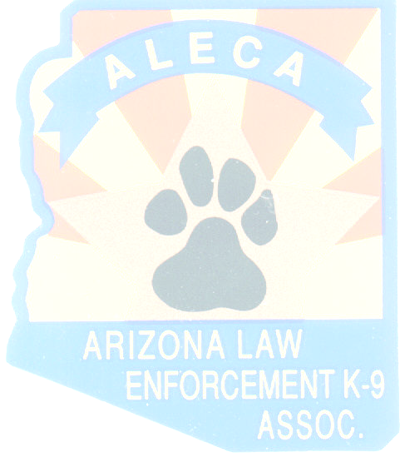
This includes a canine death if it is determined the canine died as a result of exposure to hazardous materials (i.e., dangerous drugs, toxic explosives, etc.) or conditions while performing official duties.

Not included under this definition are deaths attributed to natural causes.

In no case shall a canine be included on the memorial if the canine’s death is caused by the intentional misconduct of the officer, by an officer’s intention to bring about the canine’s death, or canine deaths attributed to an officer performing his/her duty in a grossly negligent manner at the time the canine was killed.

The Arizona Law Enforcement Canine Association (ALECA) Executive board, including the Board of Directors, will serve as the final authority in approving names included on the memorial. The ALECA board will review all names of canines and cause of death, and verify all information provided by the law enforcement agency. The board shall exhaust all reasonable means available to verify a canine’s eligibility status.

The ALECA Board will vote on canines to be added to the canine memorial on an annual basis. A majority vote shall determine a canine’s inclusion on the Arizona Police Canine Memorial.

