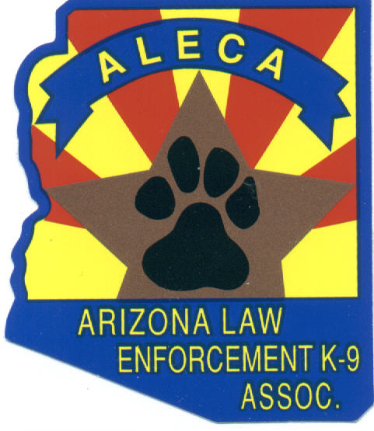 Arizona Police Canine Memorial 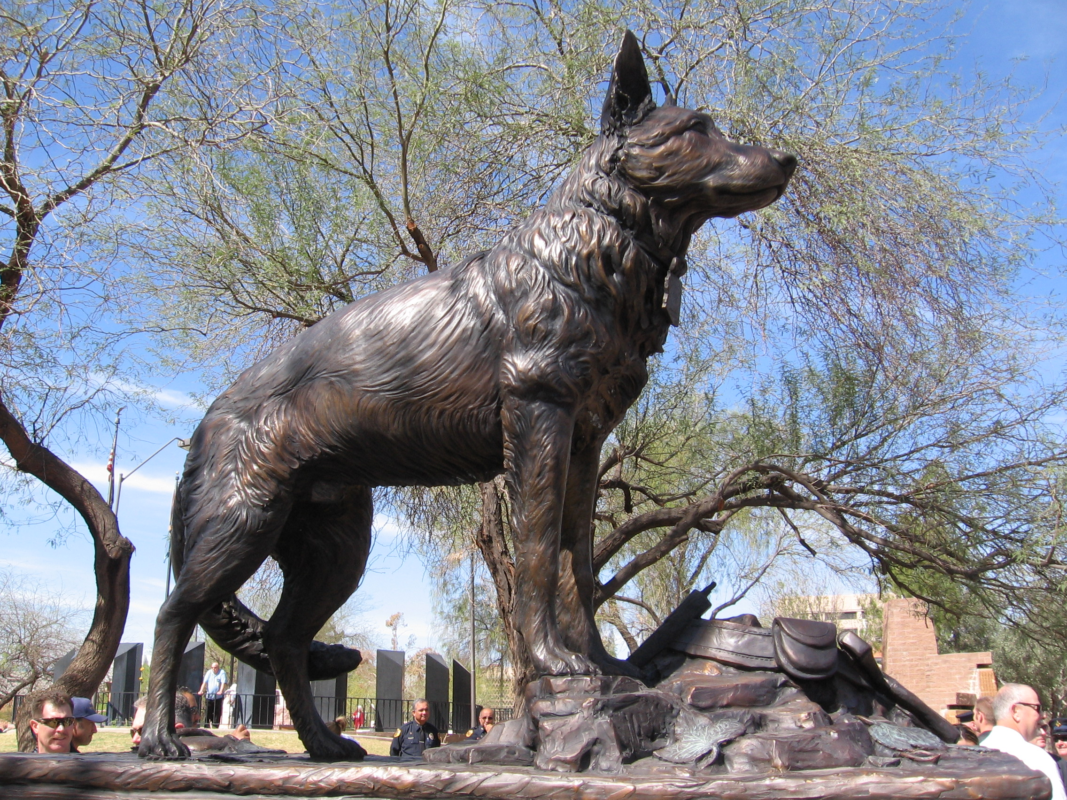
Arizona State Capitol - Wesley Bolin Plaza

SUBMISSION FORM

Request to have the Arizona Law Enforcement Canine Association Executive Board review the name of a canine that may be eligible for placement on the Arizona Police Canine Memorial.

INFORMATION
Canine’s Name _________________________________________________
Canine Handler at time of death_____________________________________ID # ____________
Department _____________________________________________________________________
End of Watch (EOW ) Date ___________________
Were the officer and canine on duty at the time of the incident? Yes No
Is this a qualifying off-duty death (refer to inclusion criteria)? Yes No
Is the canine’s handler a full-time law enforcement or corrections officer? Yes No
Does the Department recognize this loss as a line-of-duty death? Yes No
Canine’s total number of years of service in law enforcement _____________

Cause of Death ________________________________________________________________________________________________________________________________________________________________________________________________________________________________________________________________________________________________________________________________

Name of the person or group making this request

Name ______________________________________________ Phone (___) ________________
Address _______________________________________________________________________
City _____________________________________ State __________ Zip __________ - _______
Phone (___) _______________ FAX (___) ______________ e-mail ________________________
Date of Request _____/_____/______ Date Reviewed _____/_____/______

Attach information documenting the circumstances of the canine death to this page and send request to:

Arizona Law Enforcement Canine Association (ALECA)
3370 North Hayden Road #123-411
Scottsdale, Arizona 85251

